A000-Angola-Tchokwe-Mask-High ranking Ruler-with Crown and Raffia-early 20th c.

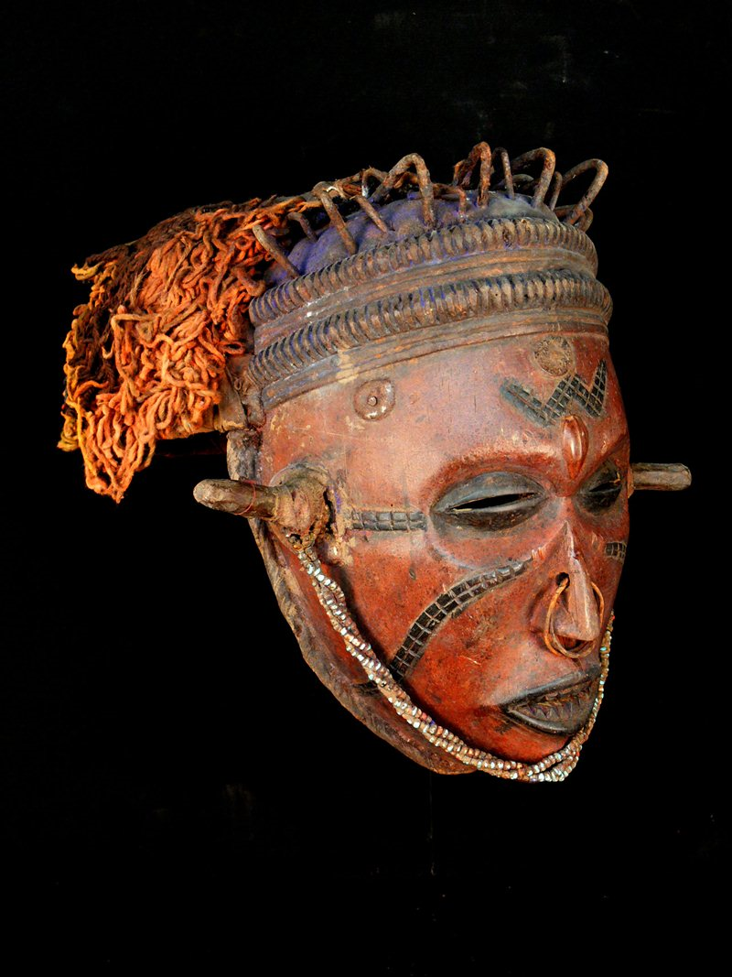 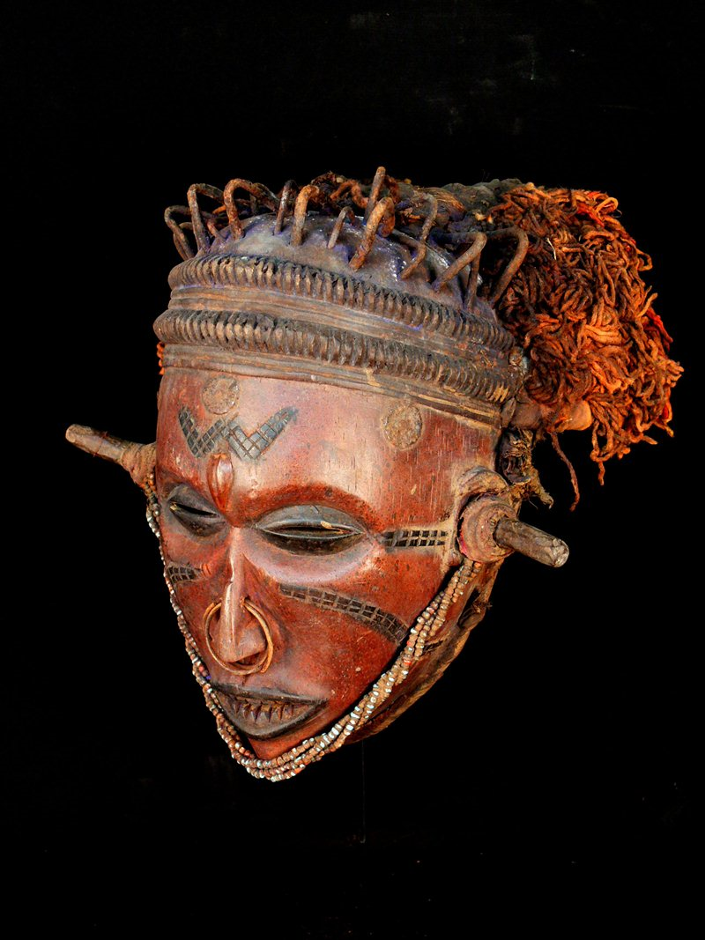

Figs. 1-2. Angola-Tchokwe-Mask-High ranking Ruler-with Crown and Raffia-early 20th c.

Case No.: 6

**Accession No.**

**Formal Label:** Angola-Tchokwe-Mask-High ranking Ruler-with Crown and Raffia-early 20th c.

**Display Description:**

This mask ofa high-ranking Ruler with a Crown and Raffia dated to the early 20th c before the Portuguese entrada is expertly carved and inlaid. The bead strings from ear to ear indicate the chief’s high rank as does his nail headdress or crown. Evidence that this mask was actually used in ritual ceremonies is suggested by the raffia still in place that head the performer’s head in position.

The Chokwe are an ethnic group of Central Africa whose ancestry can perhaps be traced to Mbundu and Mbuti Pygmies. Democratic Republic of Congo and Angola. The Chokwe were once one of the twelve clans of the great Lunda Empire of 17th- and 18th-century Angola. They eventually became independent when they refused to continue paying tribute to the Lunda emperor. Their successful trading and abundant resources caused them to be one of the wealthiest groups in Angola. By 1900 the Chokwe had dismantled the Lunda kingdom altogether, using guns they had received in trade from the Ovimbundu. The Portuguese in Angola had virtually no contact with the Chokwe until the 1930s when the Chokwe traded wax, rubber and other natural products. The Portuguese then quickly brought an end to the dominance of the Chokwe people in the region

**LC Classification:**

**Date or Time Horizon:** early 20th c.

**Geographical Area:**

**Map:**

**GPS coordinates:**

**Cultural Affiliation:**

**Media:** wood, iron, cotton, textile, glass

**Dimensions: H** 12.204 in

**Weight:** 2.51 pounds

**Condition:**

**Provenance:** Private collection

**Discussion:**

**References:**

